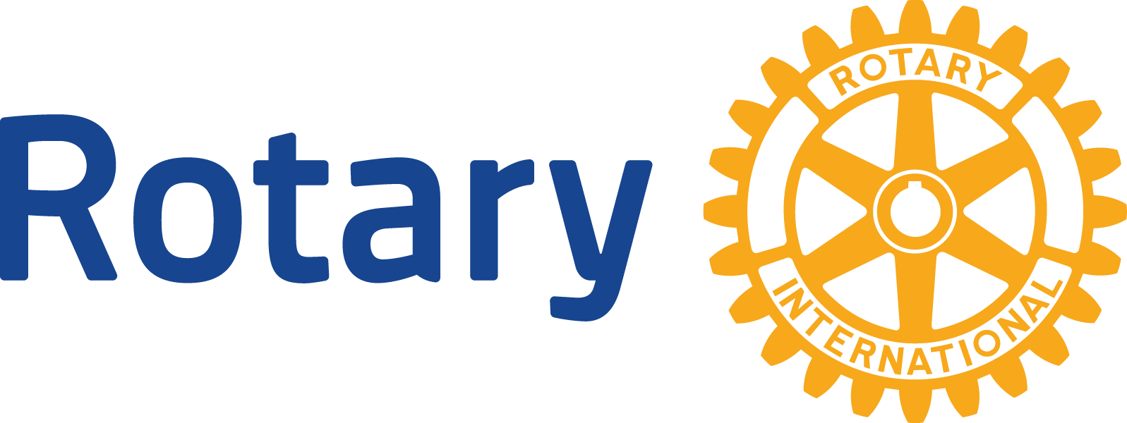
ENGLISH (EN)

GLOBAL GRANTS COMMUNITY ASSESSMENT RESULTS

Use this form to report community assessment findings to The Rotary Foundation when you apply for a global grant.
Assessing the strengths, weaknesses, needs, and assets of the community you plan to help is an essential first step in designing an effective and sustainable global grant project. See Community Assessment Tools for full instructions and helpful tips.
This form will help you report the results of your community assessment, and it’s required when you apply for any humanitarian or vocational training team grant. Complete a separate form for each beneficiary community (e.g., school, health care system, or village), using information that is both current and specific to each community. Remember, you can’t use global grant funds to cover the cost of doing an assessment, but you can use district grant funds.

COMMUNITY OVERVIEW
Describe the characteristics (such as geographic information, main sources of income, population size, and access to education and health services) of the specific community where this project will take place.
Yuli, Hualien
According to the statistics released by the Ministry of Health and Welfare for the year 2022 111, the death rate due to nephritis, nephrotic syndrome, and renal failure in Hualien County was 34.0 per 100,000 population, whereas the national average was 24.9 per 100,000 population. From the perspective of mortality rates, kidney-related death rates in Hualien County surpass the national average. Notably, Yuli Township in Hualien County had a death rate of 57.4 per 100,000 population for nephritis, nephrotic syndrome, and renal failure, exceeding the county's average. Hence, we have selected Yuli Township as the location for our project. Through kidney disease screening and health education workshops, our aim is to enhance residents' awareness of kidney diseases, provide relevant health education information, and ultimately reduce the prevalence of kidney-related conditions in the Hualien region.
Yonghe District, New Taipei City
Typically, after being diagnosed with chronic kidney disease by a physician, depending on the stage of CKD, kidney patients are offered the option to join either an early-stage Chronic Kidney Disease Improvement Program or a Pre-End-Stage Renal Disease (Pre-ESRD) patient care and education program. These programs provide appropriate kidney disease care and education. According to the statistics of National Health Insurance Administration, only half of pre-ESRD patients and approximately 10% of early CKD patients enter these educational program.

In addition, given that the mortality rate due to nephritis, renal syndrome, and renal disease in Yonghe District, New Taipei City, is 25.8 per 100,000 population, surpassing the national average of 24.9, we have decided to conduct the chronic kidney disease education courses and chosen this area to organize a renal health education seminar. The aim of this initiative is to provide educational courses for individuals with chronic kidney conditions, encompassing disease-related knowledge and dietary guidance, in order to assist them in slowing down the progression of kidney function deterioration.

COLLECTING COMMUNITY ASSESSMENT DATA
When you conducted the assessment, who in the community did you speak to? At least two different community representatives and beneficiaries who are not involved in Rotary (such as teachers, doctors, or community leaders) should be included in the discussions.
local healthcare professionals, community leaders, and residents.

When in the last year did the discussions occur?
N/A

What methods did you use to collect information from community members (such as community meetings, interviews, or focus groups)?
community meetings, interviews, and government public statistics.

TARGET POPULATION
Who will benefit directly from the project? List the groups that will benefit (such as schools, hospitals, vocational training centers, cooperatives, or villages).
Residents of Yuli, Hualien and Yonghe District, New Taipei City
Describe the process of how the beneficiaries were identified.
This project consists of two main components. Firstly, there is a comprehensive preventive screening and education program aimed at the local community residents. Through screening, we aim to detect kidney function abnormalities earlier early and assist individuals in seeking medical attention promptly. Simultaneously, through the educational program, we strive to convey knowledge about kidney function to the public, help them better comprehend test reports, and guide them in establishing correct lifestyle habits to safeguard kidney health.

Secondly, we are focusing on providing an educational course tailored for individuals with chronic kidney disease, addressing the specific needs of this group. This course will cover disease-related information as well as dietary guidance. For those with chronic kidney disease, a thorough understanding of the condition is crucial, along with establishing proper medication usage habits and adhering to principles of a low-protein diet to slow down the progression of kidney deterioration – all of which are vital objectives. During this project, we can manufacture a series of e learning video stored on our website that chronic kidney disease patients can learn how to deal with their chronic kidney disease regarding low protein diet preparation, proper medication usage, awareness of kidney disease and prevention of kidney disease progression.

COMMUNITY STRENGTHS, NEEDS, PRIORITIES, AND PROJECT DESIGN
Describe what members of the community said matters to them during the assessment.
- How to determine if I have kidney disease.
- How to protect my kidneys.
- How to control kidney disease.
- How to follow a kidney disease diet.
- How to achieve a balance between managing the disease and living my life.
Describe the community’s strengths and resources.
The community owns health bureau, township office, OPD clinics, small sized hospitals responsible for health care of citizens. Citizens living in remote area such as Yuli, Hualien, shares medical discount.

Describe any challenges and gaps in the community’s behaviors, skills, and knowledge.
- Insufficient awareness of kidney disease.
- Low participation rate in adult health check-ups.
- Lack of comprehensive understanding of kidney disease diets.
- Misconceptions about kidney disease prevention and management diets.

What issues will the project address, and how does the community currently address those issues?
Comprehensive preventive screening and education program
Through this program, residents can gain an understanding of their own biochemical test results, body composition analysis, and what they signify. The parameters include hemoglobin, hematocrit, creatinine - kidney function, blood urea nitrogen, uric acid, total cholesterol, triglycerides, blood glucose, high-density lipoprotein cholesterol, low-density lipoprotein cholesterol, urine protein, urinary occult blood, urinary glucose, quantitative urine protein testing, basal metabolic rate, skeletal muscle mass, body fat percentage, regional muscle fat analysis, visceral fat level, and waist-to-hip ratio.
Biochemical test results can be obtained through participating in free public adult health check-ups or by self-payment at hospitals or clinics. However, less than 20% of adult participate in free public adult health check-up. Body composition analysis, on the other hand, requires self-payment at locations such as hospitals, clinics, sports centers, or fitness centers equipped with body composition analysis instruments.
Educational course for chronic kidney disease
Through this program, kidney patients can gain access to the correct methods of kidney disease care, including medication administration and habits, dietary principles and implementation, and adjustments to their lifestyle. This enables kidney patients to manage kidney disease and reduces the risk of rapid deterioration due to trial and error with unproven remedies more easily.
Typically, after being diagnosed with chronic kidney disease by a physician, depending on the stage of CKD, kidney patients are offered the option to join either an early-stage Chronic Kidney Disease Improvement Program or a Pre-End-Stage Renal Disease (Pre-ESRD) patient care and education program. These programs provide appropriate kidney disease care and education. According to the statistics of National Health Insurance Administration, only half of pre-ESRD patients and approximately 10% of early CKD patients enter these educational program.
However, due to issues such as staffing constraints in hospitals or clinics, low patient willingness to participate, and infrequent follow-up visits, many some kidney patients lack comprehensive information on how to control kidney disease and adjust their diet. Consequently, many some kidney patients may have difficulty struggle to effectively manage their condition.

Provide the specific details of the project design and how it will solve these issues.
Specific details of the project design:
This project aims to enhance awareness about kidney health and preventive measures through two main components. Firstly, we will implement a preventive screening and education program for the community members, aiming to detect kidney function abnormalities earlier early and provide assistance while educating them about adopting healthy lifestyle habits. The second part focuses on providing educational courses for individuals with chronic kidney disease, including kidney disease-related knowledge and dietary guidance, to help them slow down the progression of kidney dysfunction.
Solve issues:
Increasing community residents' awareness about kidney health, enabling them to prevent kidney diseases and recognize early signs.
Assisting individuals with chronic kidney disease in understanding their condition and providing them with necessary medical knowledge and lifestyle guidance to manage their disease.
Facilitating early diagnosis of chronic kidney disease, contributing to timely treatment and management.
Reducing the health and economic impacts of kidney diseases on individuals and the community.
This project will benefit community residents, individuals with chronic kidney disease, and society at large. By providing knowledge, early intervention, and promoting healthy habits, we aim to improve individual quality of life, lessen the burden of the disease, and contribute to the long-term health development of the community.

Describe the long-term plan for the project (such as oversight, financial responsibilities, and expected behavior change) after Rotary’s involvement ends.
We expect to promote the awareness of kidney disease, increase percentage of adults to receive public free adult health check -up, enhance the low protein diet adherence and medication usage for CKD patients We will follow up the disclosed CKD patients for half year to see the outcome of this project. We will also keep the project and keep educate people through further screening and educational program and enhancing CKD educational course and e learning of kidney disease knowledge, low protein preparation principle, CKD educational course, medication usage adherence etc. through the multidisciplinary educational material and information on the website of Taiwan Kidney Foundation .

ENVIRONMENTAL ASSESSMENT (FOR ALL ENVIRONMENT AND WATER, SANITATION, AND HYGIENE PROJECTS)
What are currently the greatest environmental threats to local land, air, water resources, and the ecosystem?
Yuli, Hualien
According to the statistics released by the Ministry of Health and Welfare for the year 2022 111, the death rate due to nephritis, nephrotic syndrome, and renal failure in Hualien County was 34.0 per 100,000 population, whereas the national average was 24.9 per 100,000 population. From the perspective of mortality rates, kidney-related death rates in Hualien County surpass the national average. Notably, Yuli Township in Hualien County had a death rate of 57.4 per 100,000 population for nephritis, nephrotic syndrome, and renal failure, exceeding the county's average. Hence, we have selected Yuli Township as the location for our project. Through kidney disease screening and health education workshops, our aim is to enhance residents' awareness of kidney diseases, provide relevant health education information, and ultimately reduce the prevalence of kidney-related conditions in the Hualien region.
Yonghe District, New Taipei City
Given that the mortality rate due to nephritis, renal syndrome, and renal disease in Yonghe District, New Taipei City, is 25.8 per 100,000 population, surpassing the national average of 24.9, we have chosen this area to organize a renal health education seminar. The aim of this initiative is to provide educational courses for individuals with chronic kidney conditions, encompassing disease-related knowledge and dietary guidance, in order to assist them in slowing down the progression of kidney function deterioration.

List any cultural practices that are relevant to the project (such as agricultural techniques or traditions).
Kidney Knowledge, Kidney Disease Diagnosis, Balanced Diet, Kidney Disease Diet, Healthy Lifestyle Habits, Renal Care

What positive and negative environmental changes do you expect to result from the project?
- Understanding Kidney Health Status
- Familiarizing with Kidney Knowledge
- Learning How to Diagnose Kidney Disease
- Learning Healthy Dietary Patterns
- Adopting a Healthy Lifestyle
- Understanding Medications for Kidney Disease
- Understanding Diet for Kidney Disease
- Understanding Daily Care for Kidney Disease
- Learning How to Achieve Balance between Illness and Life

